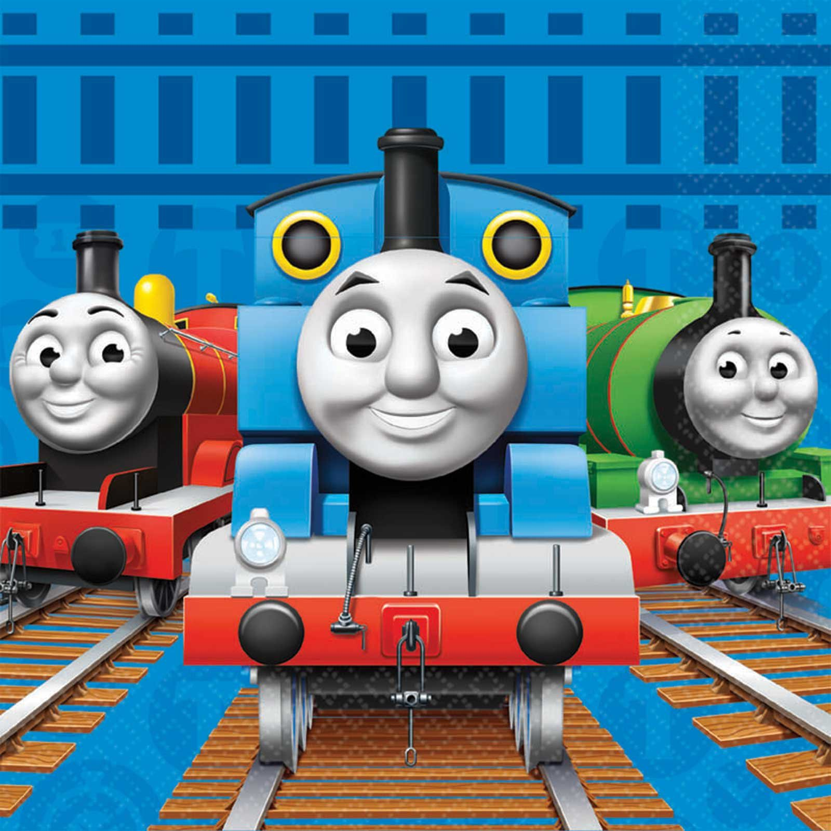
Station #1
Photoboothh

Dress like Sir Topham Hatt,
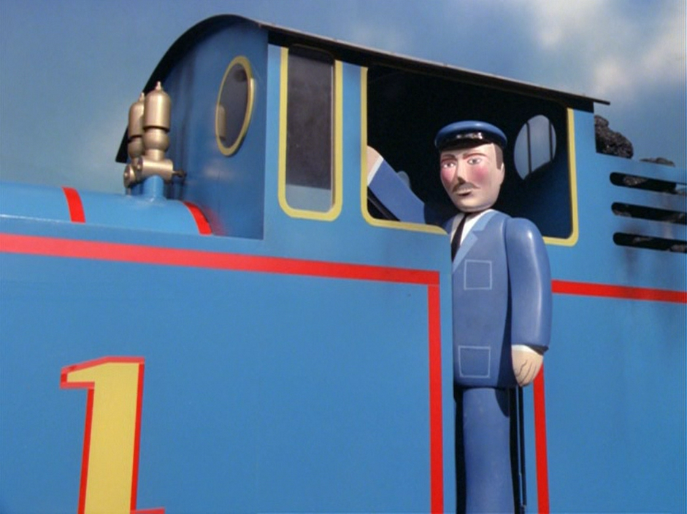
a train engineer,

or a fancy passenger,
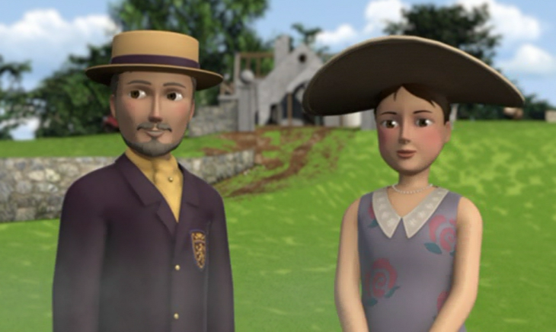

and take your picture with Thomas and Percy!

Trains
Station #2

Drive Thomas and his friends around the Island of Sodor.
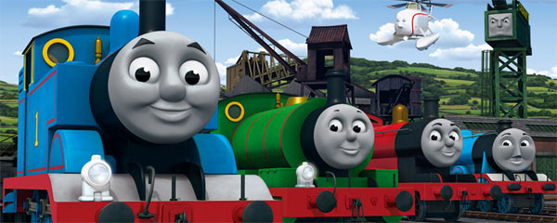

They love to be really useful engines.
Books & Games
Station #3

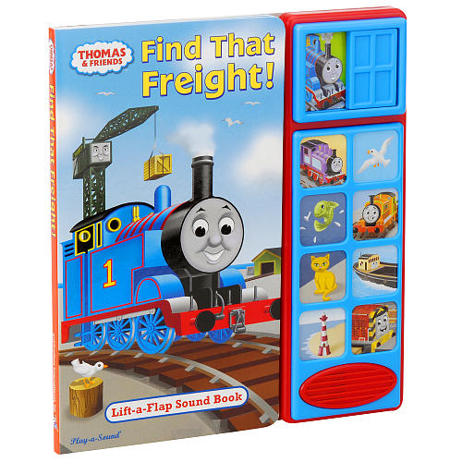
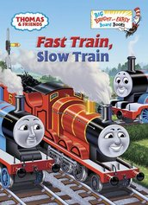
Read about Thomas and his friends.
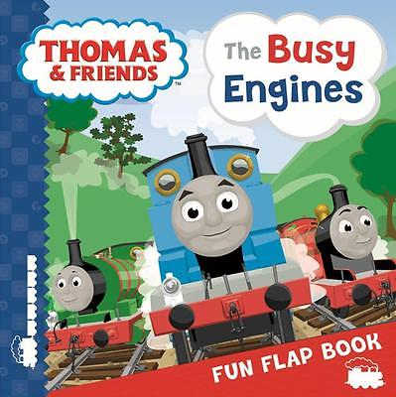

Then you can put together a puzzle or play a match game of the trains.
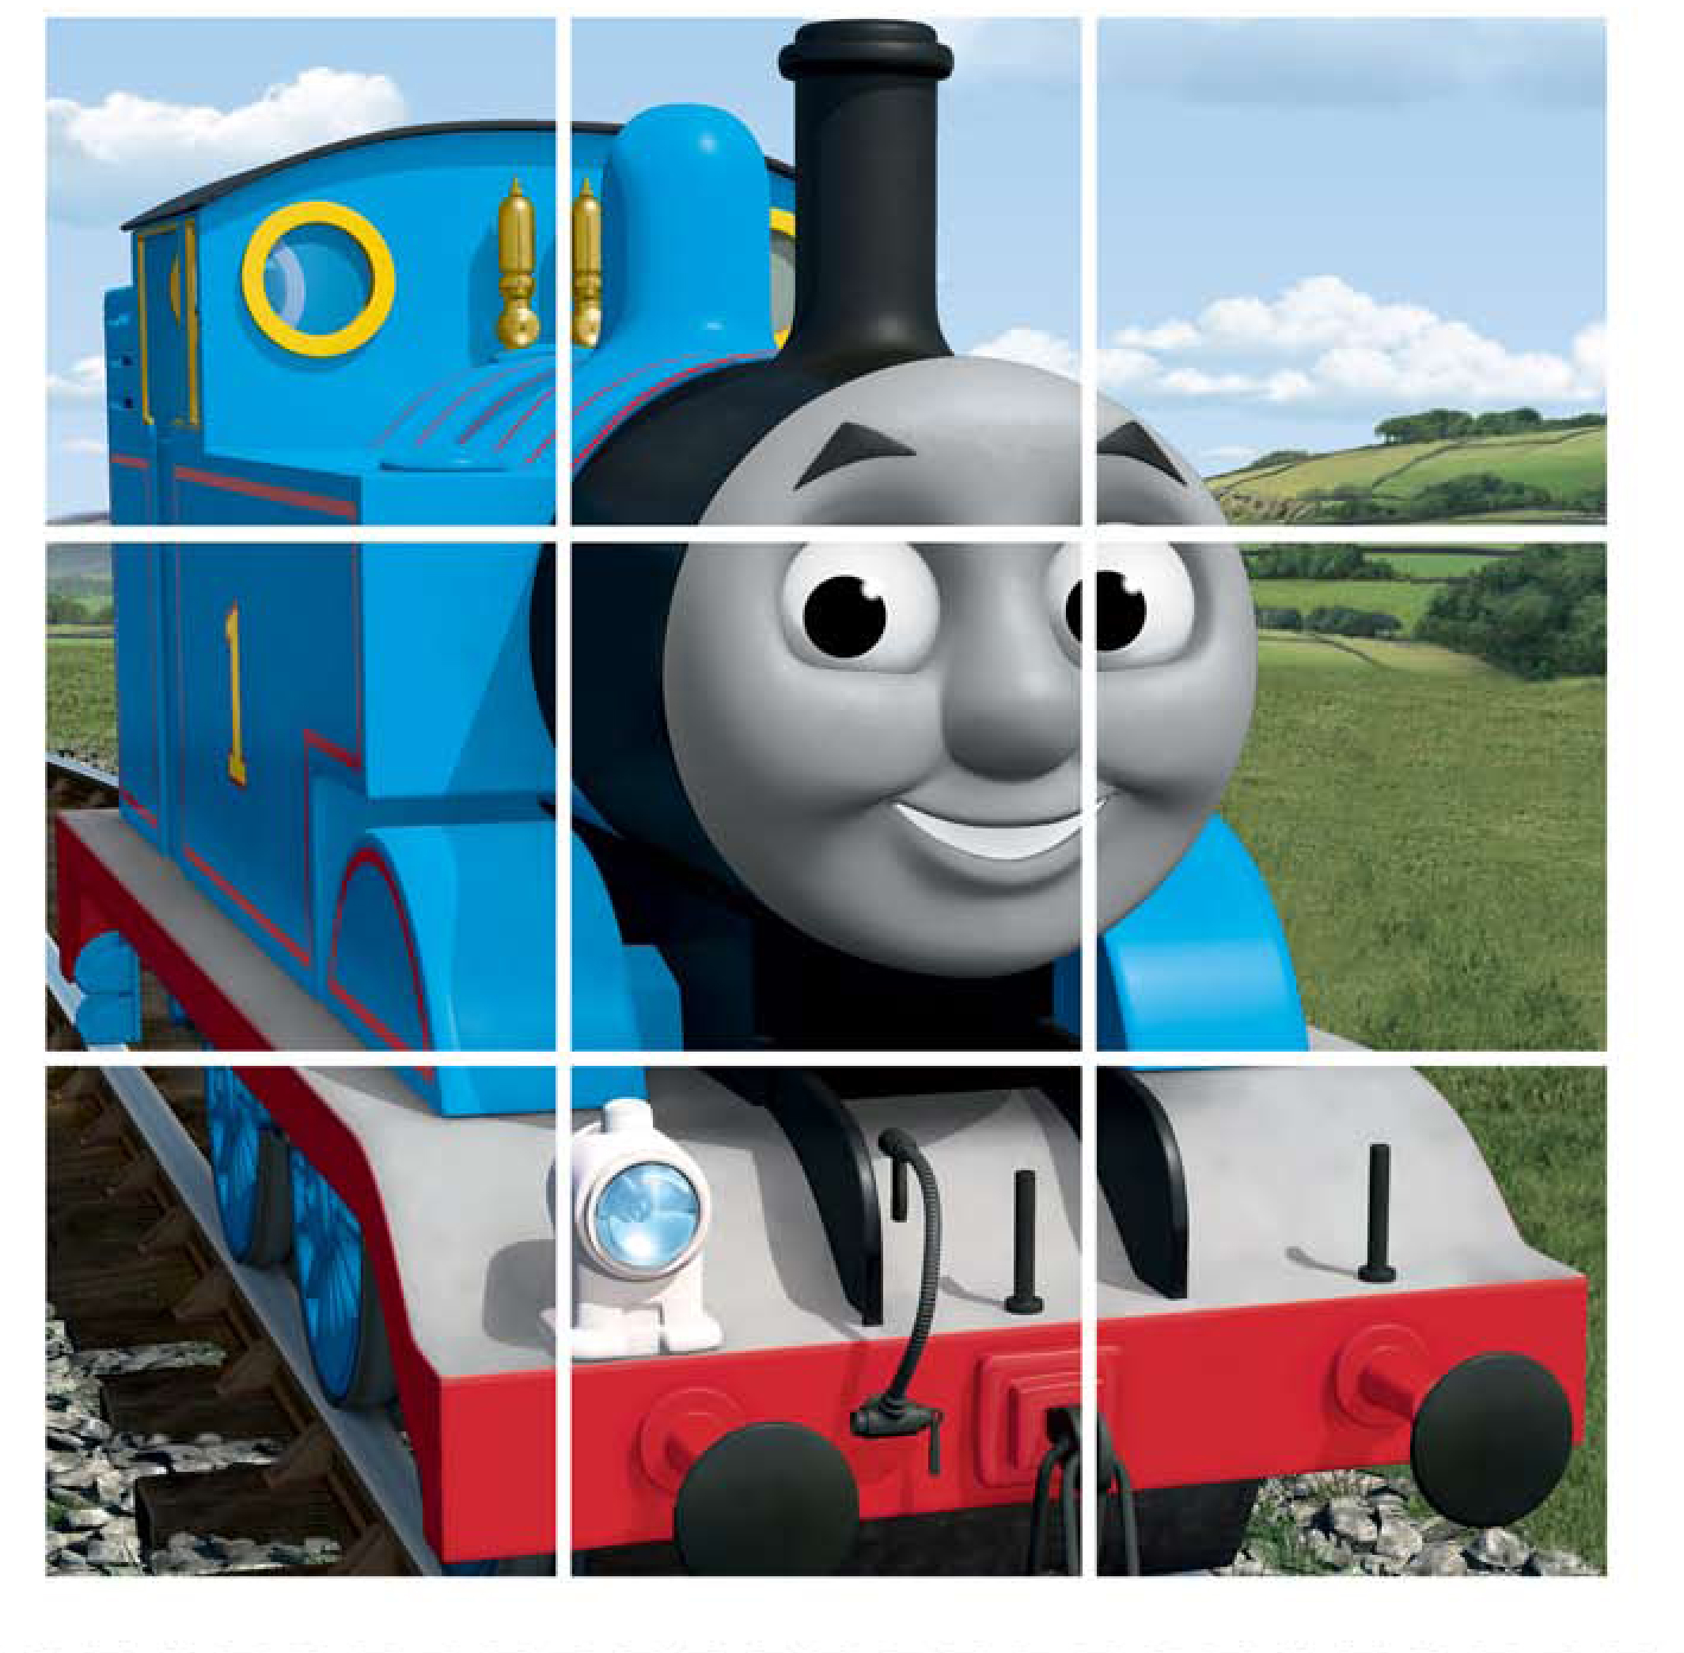
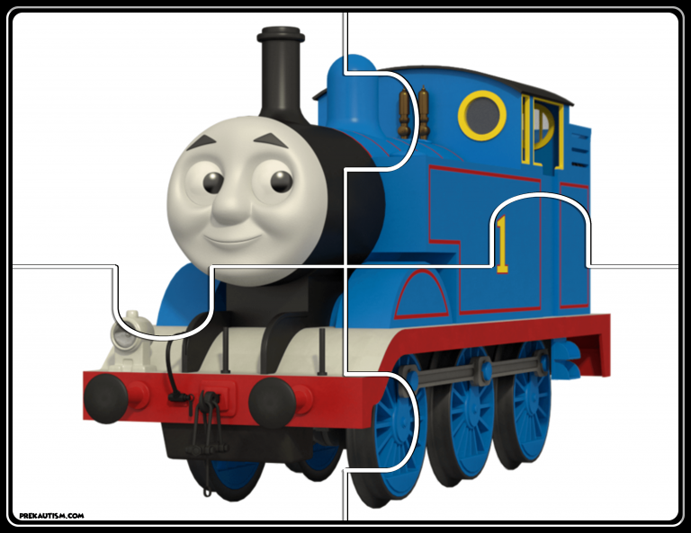

Playdoh
Station #4

Make a playdoh train and tracks.
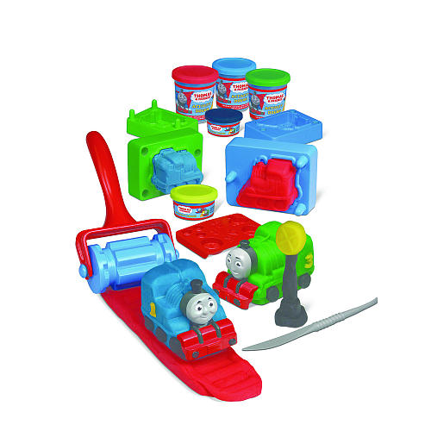

Station #5
Coloring

Color a picture of Thomas and his friends.
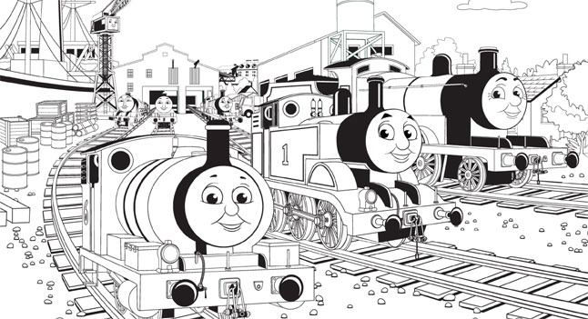

You can also use stickers and crayons to make your own pictures of the Island of Sodor.

Toss Game
Station #6

Toss the Coal in the Hole

- Find a friend. Each person should take 3 pieces of coal.
- Stand behind the line and take turns tossing your coal into Thomas’s firebox.
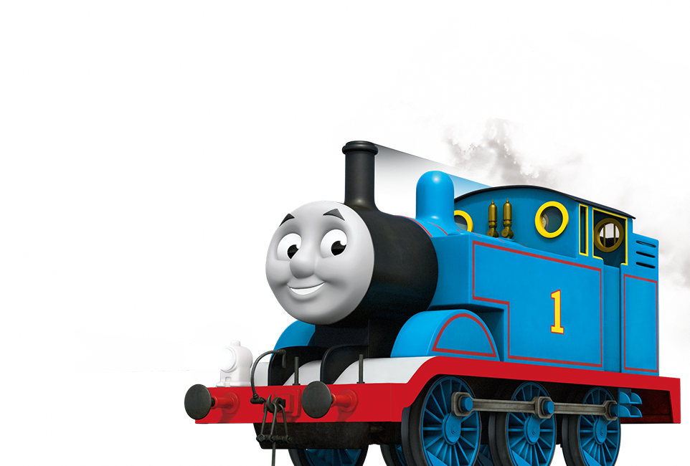
- The person with the most coal in the firebox wins!

