Homeschool Preschool Daily Schedule
7:00 – 8:00 | Wake up, get ready, breakfast, morning play time
8:00 – 9:00 | TV time/Mom works
9:00 – 10:00 | Play time together 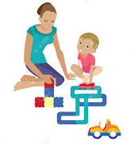
10:00 – 11:00 | Read books and Learning activity
11:00 – 11:30 | Independent play/Mom works
11:30 – 12:00 | Chores
12:00 – 12:30 | Lunch
12:30 – 1:30 | Play outside or exercise inside
1:30 – 3:00 | 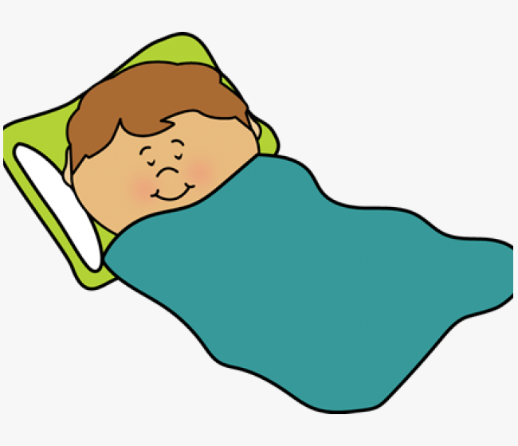Nap time/quiet time/ Mom works
3:00 – 4:00 | Creative activity (craft, sensory play, baking)
4:00 – 5:00 | Independent play/Mom works
5:00 - 6:30 | Play time together
6:30 – 7:15 | Dinner
7:15 – 8:00 | Family time
8:00 | Bedtime

